**PROJECT REPORT**

**Technology and Standards for Geospatial Workflow**

**CROP INSURANCE WORKFLOW**



**Submitted by:**

Akanksha Singh (M.Tech ASD)

Vanamadi Sandhya Rani (M.Tech ASD)

Shreyas Sajeev T (M.Tech FED)

**Submitted to:**

Mr. Shiva Reddy Koti

Scientist/Engineer – SE

Geoinformatics Department,

IIRS, Dehradun

**Crop Insurance Workflow**

**Introduction:**

Agriculture is exposed to frequent risks of crop damage all around the world. In such a case, the idea of crop insurance schemes and their implementations have played an important role in agricultural risk assessments. Agricultural risk assessments have been there in different countries in different decades and time periods ​(Skees, 2005)​. Still there have been continuous improvements in the ways and approaches a crop insurance scheme is designed and the ways it’s assessed. With more and more technological advancements, the need for developing more innovative and sound crop insurance products which will be useful for both developed and developing nations is required ​(Leblois et al., 2014). Better agricultural risk management is required to address the current challenges of food security, farmer’s income security, and climate resiliency in agriculture.

**Scope of Remote Sensing and GIS data in** **Crop Insurance:**

* When farmers file insurance claims due to crop damage or loss, remote sensing data can be used to validate the extent and severity of the claimed damage. By comparing pre-event and post-event satellite imagery or aerial surveys, insurers can assess the accuracy of the claims and determine the appropriate compensation. This process helps in reducing fraudulent claims and ensures that legitimate claims are properly evaluated.
* GIS tools are used to accurately document and manage crop insurance related data, including policy details, insured areas, claims history, and payouts. By utilising spatial data management systems, insurers can efficiently process claims, track policyholder information, and maintain accurate records for auditing purposes.

**Objectives:**

1. To assess the workflow of a crop insurance scheme in the flood affected area.

2. To check whether the crop loss claim made by the farmer is genuine or not.

3. To compute the total area of agriculture fields affected by floods in an Insurance Unit.

4. To develop a web portal to be used by the insurance company to assess the flood damage in a specified Insurance Unit (IU).

**Problem Addressed:**

Making false claims of crop insurance is illegal and considered insurance fraud. Although majority of farmers are honest and follow proper procedures when filing crop insurance claims. However, fraudulent claims can have negative consequences for both the farmers involved and the insurance industry as a whole. It can lead to increased premiums for all farmers, reduced trust in the insurance system, and potential legal repercussions for those involved in fraudulent activities.

To address this problem, insurance companies follow rigorous investigation for which remote sensing and GIS data can be used as a means of preliminary testing of genuinity of the claim made by the farmer before conducting in-situ field surveys.

**BPMN (Business Process Model and Notation)**

The BPMN we created for crop insurance companies is as follows:

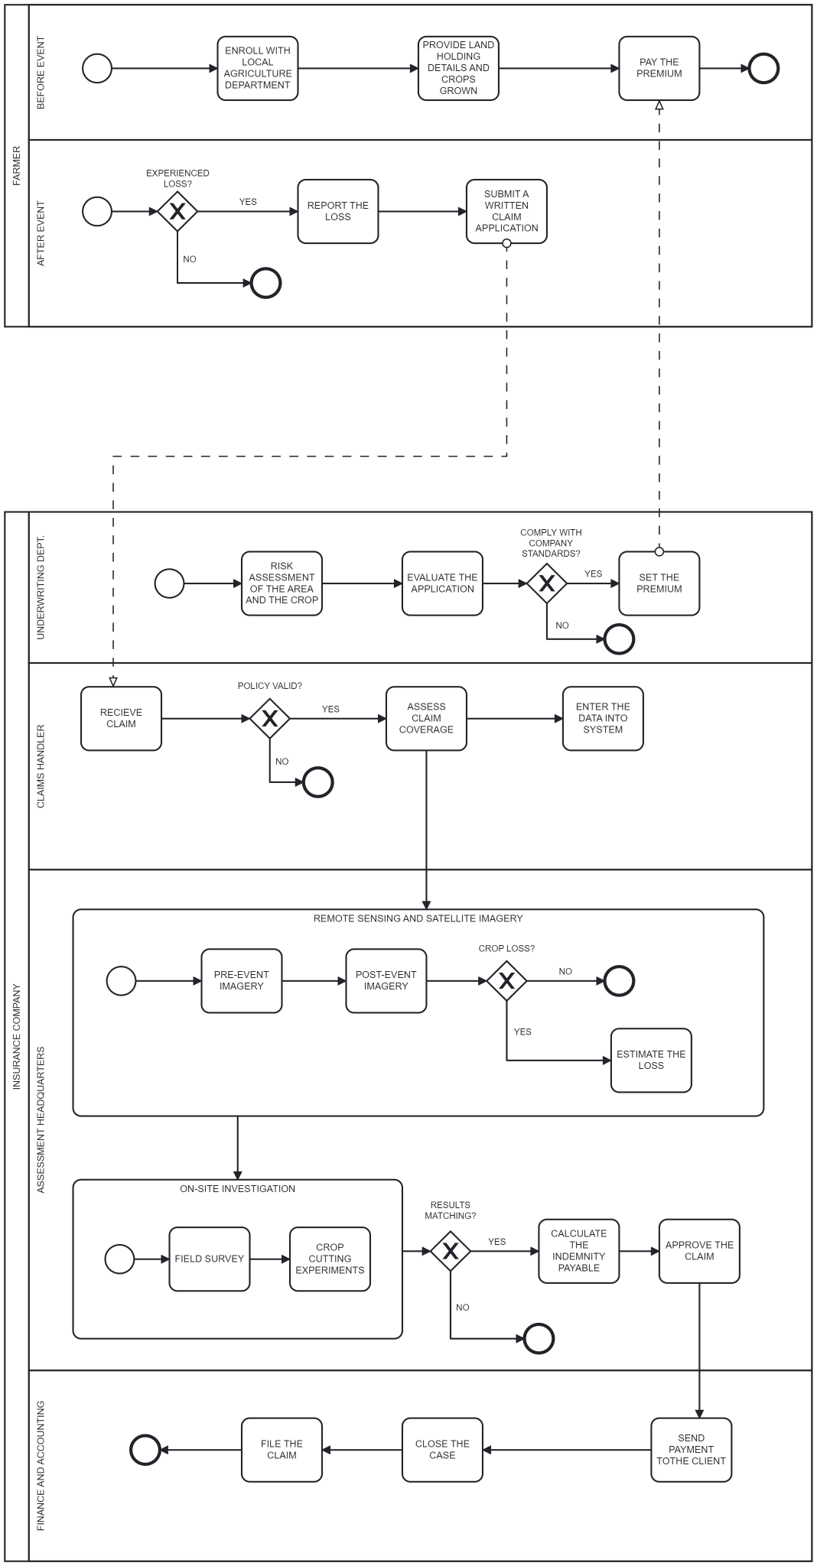

**METHODOLOGY:**

**STUDY AREA**

Kerala's Alappuzha District (9.4981° N, 76.3388° E) was used as a key research region for understanding the 2018 Kerala floods and the problems the farmers would have faced in getting the insurance for their crops. The area, which is referred to as the "Venice of the East" because of its large system of canals and backwaters, experienced significant flooding as a result of the disaster. Due to its low-lying terrain and large population, Alappuzha was susceptible to flooding, which severely damaged its infrastructure, agriculture, and way of life.

**DATA and TOOLS used**:

**Data used**:

1. Sentinel 1-SAR GRD dataset.
2. Seasonality layer of JRC Global Surface Water Mapping Layers, v1.4, 30m resolution.
3. WWF HydroSHEDS Void-Filled DEM, 3 Arc-Seconds, 30m resolution.
4. District and Taluka level vector shapefiles.
5. CHIRPS Pentad: Climate Hazards Group InfraRed Precipitation With Station Data (Version 2.0 Final), 6 km resolution.
6. Dynamic World V1 10m LULC from Sentinel-2.

**Tools used:**

1. Google Earth Engine
2. QGIS
3. Apache Tomcat
4. Geoserver
5. Mapstore
6. Streamlit library of Python
7. Camunda platform
8. Lucidchart

**PROCEDURE:**

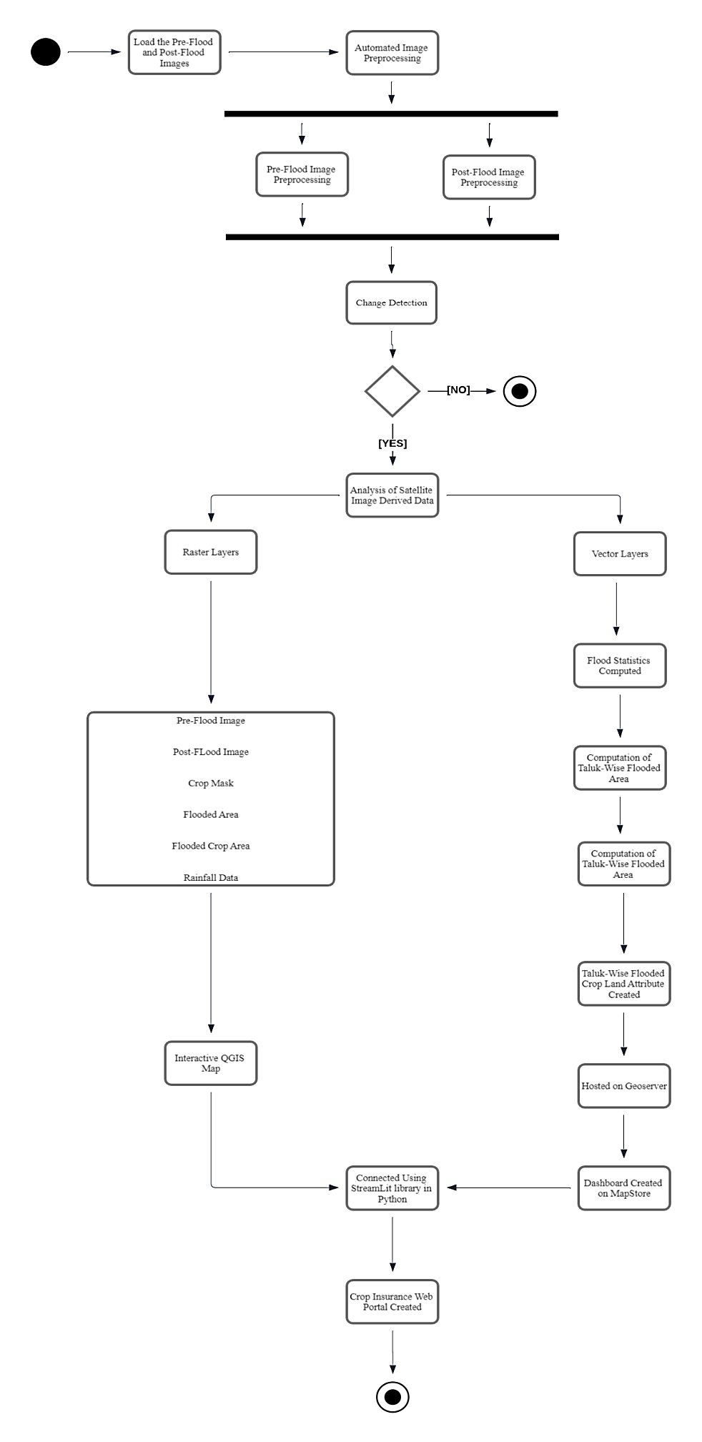

**UML Diagram of The Implemented Workflow**

1. **Data collection:**

All the required datasets were processed in Google Earth Engine and were exported.

1. **Creation of raster layers:**

The following layers after exporting from Earth Engine were used to display in the final WMS:

* Before-flood image.
* After-flood image.
* Flood mask.
* Crop mask.
* Flooded crop mask.
* Rainfall over the flood month.

1. **Creation of vector layers:**

From the raster data, different attributes were computed for each taluk of Alappuzha district such as:

* Average amount of rainfall received.
* Area of each taluka.
* Area of cropland in each taluka.
* Area of flooded land in each taluka.
* Area of crop under flood.

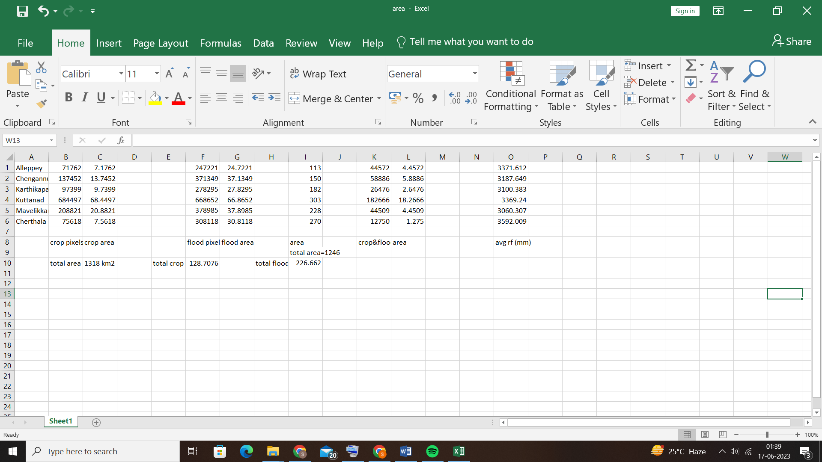

The values were updated in the attribute table of the taluka level shape file of Alappuzha.

1. **Dashboard Creation:**

**Qgis2Web:**

* The raster files imported by GEE were made into an interactive web map using the qgis2web plugin in QGIS software.
* The Leaflet design was used to export the interactive map. Features like zoom in and out, geolocating users, distance and length measurement on the map were added for the insurance companies to assess the damaged areas carefully.

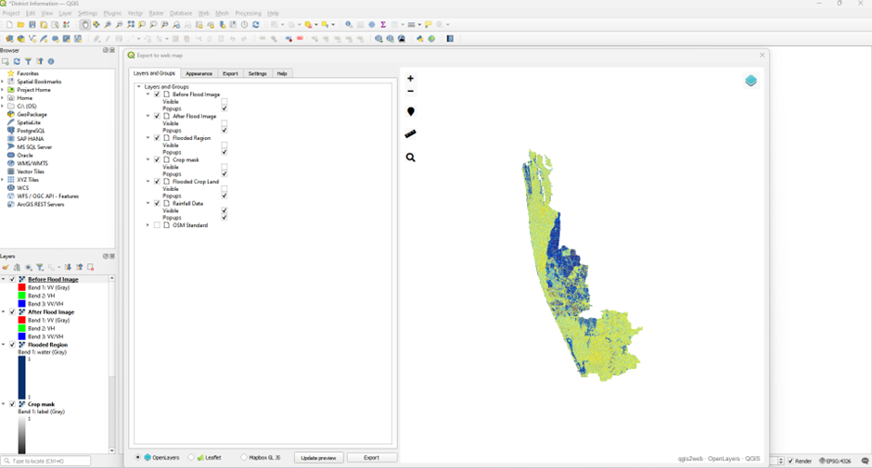

**Geoserver:**

* Geoserver, openlayers and mapstore were downloaded and installed in the webapps folder of apache tomcat application server.
* Apache tomcat is an application server that provides a platform for java based applications.
* Geoserver was used to publish our data in the form of WMS (Web Map Service).
* Openlayers library was used to display maps from the WMS.
* Mapstore was used to create an interactive dashboard.

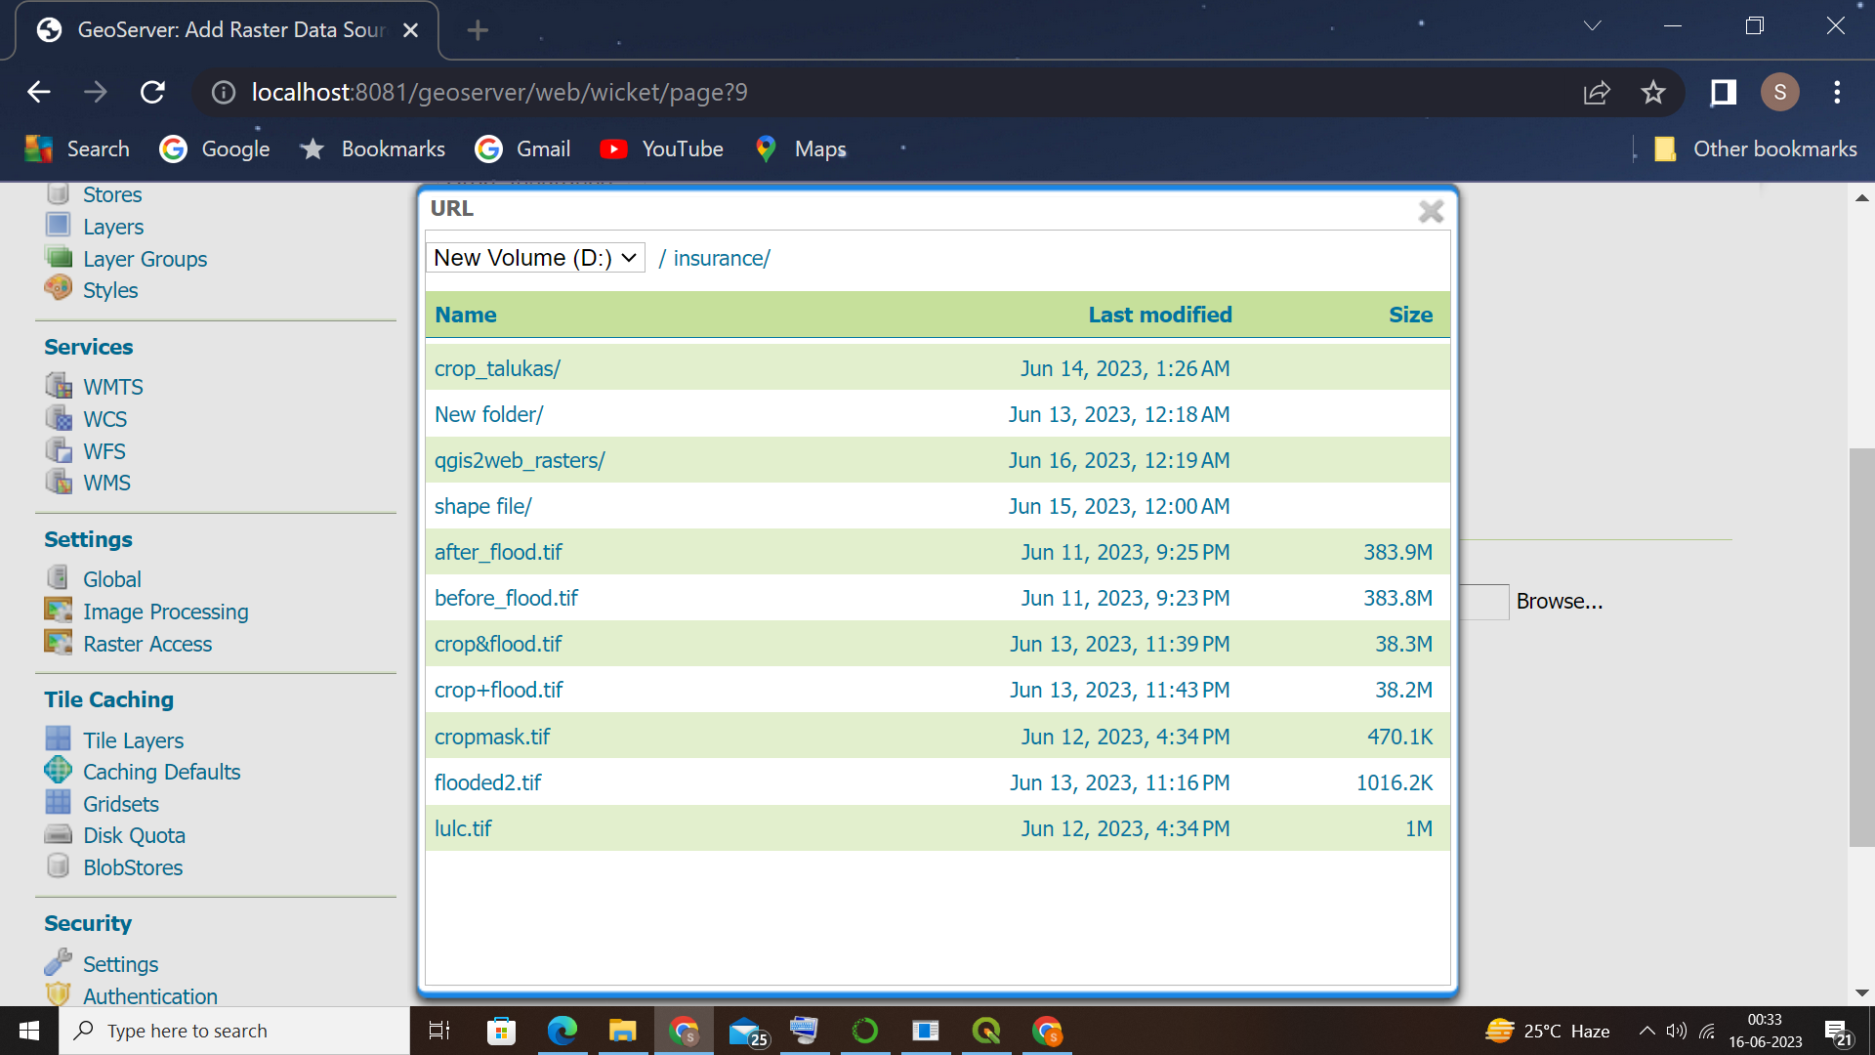

1. **Connecting all the datasets:**

* Streamlit library was installed in python programming language to create interactive web application.Python script is then developed for required interactive dashboard creation. The code is then run from the terminal.
* Subsequently, two dashboards are created handling farmer and the insurance company data. The dashboards are made and then linked together. The information passed from the dashboard is used for verification of claims put forward by farmers by looking into the raster and vector database.
* Insurance company web portal takes us to vector statistics web application and raster layer of flood inundated crop fields. The URLs to these dashboards are embedded in the python code scripts.

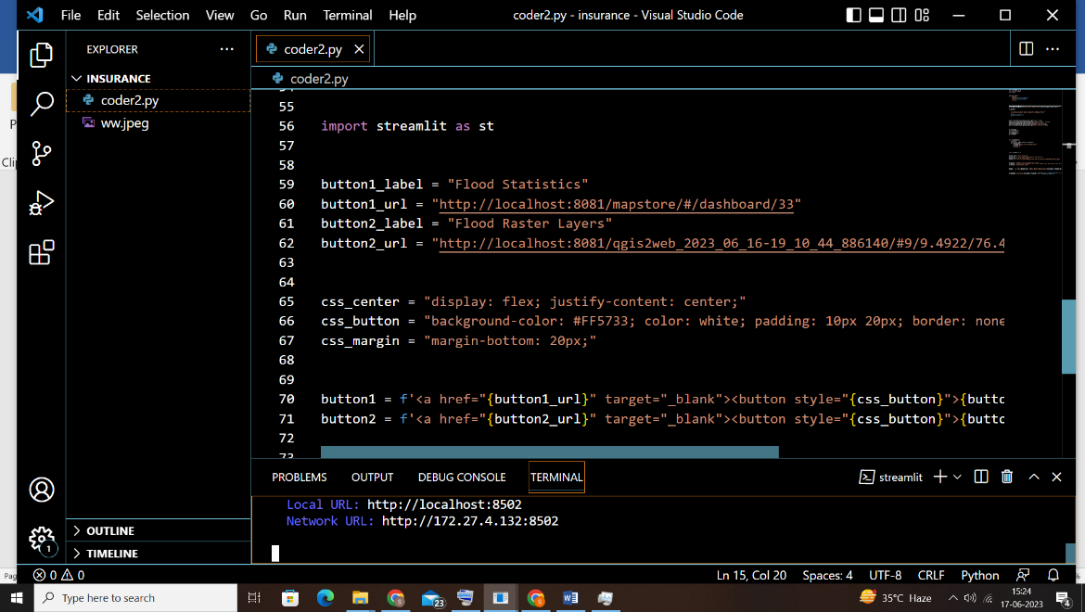

**Results and Discussion:**

* The total flooded area in the district was 22660 ha.
* The flood loss in the Alappuzha district was computed for agriculture and other areas. The total crop area affected by the flood was 3698 ha.
* The geo-portals for both the farmer and the insurance company were successfully made and tested.

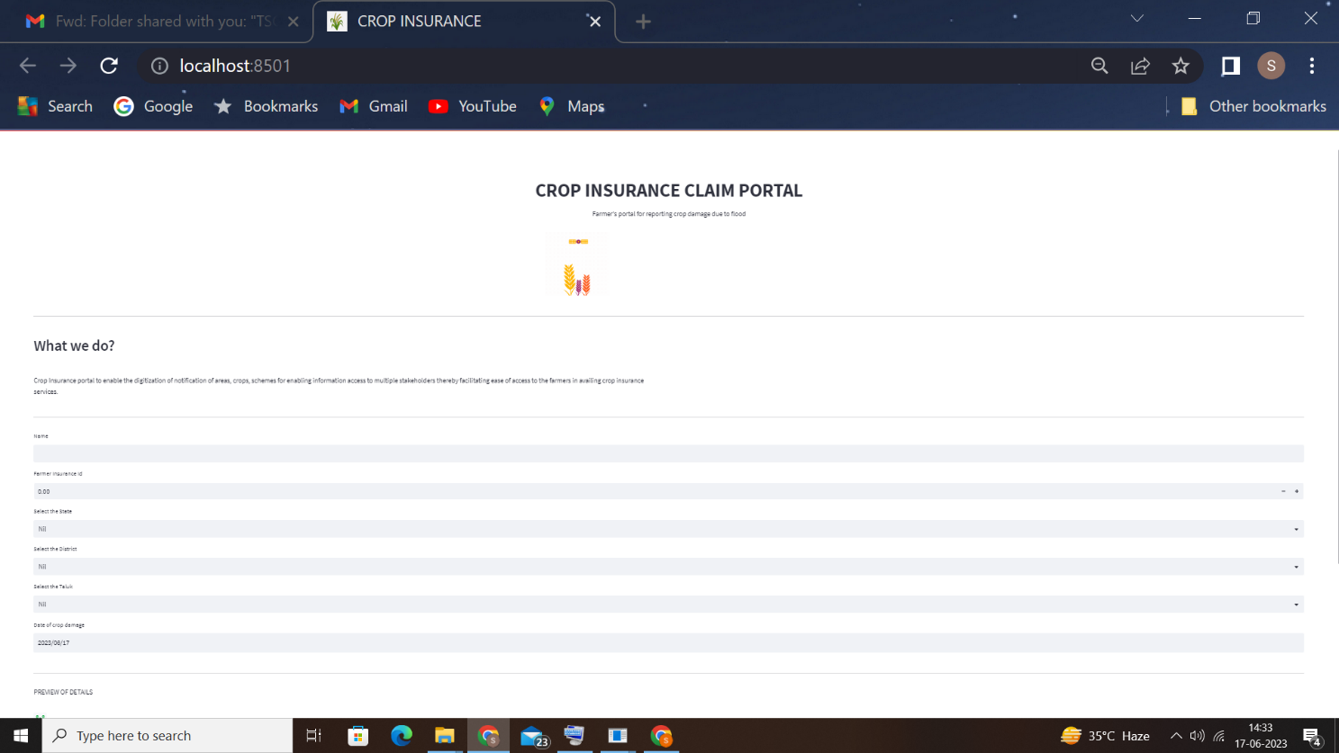

Figure 1: Farmer's portal

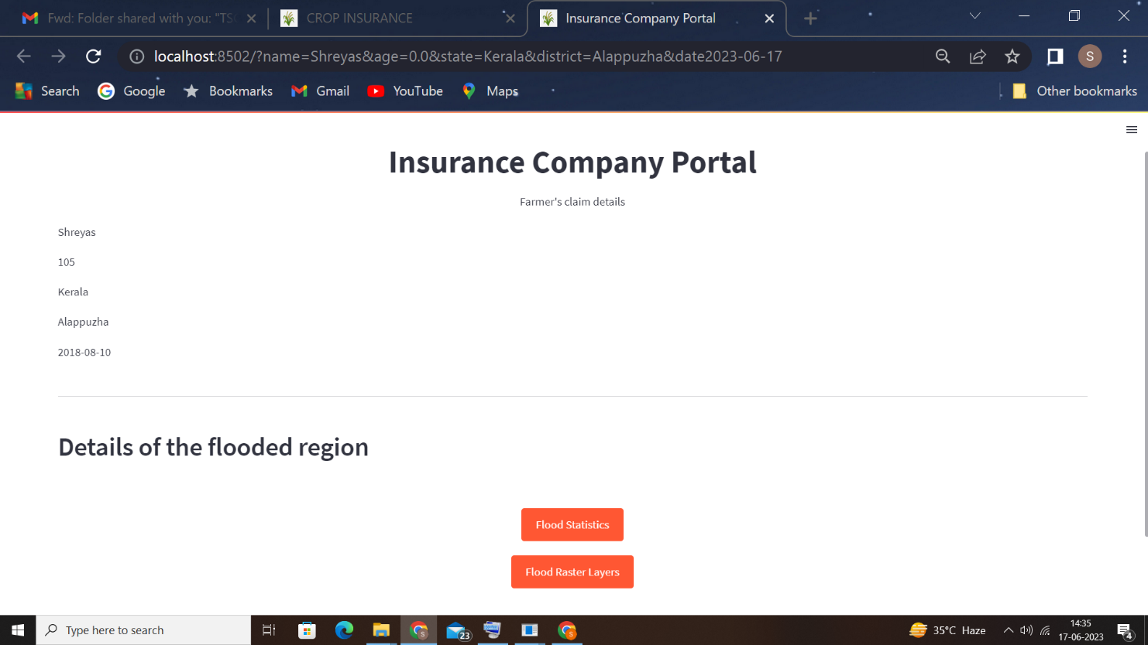

Figure 2: Insurance company portal

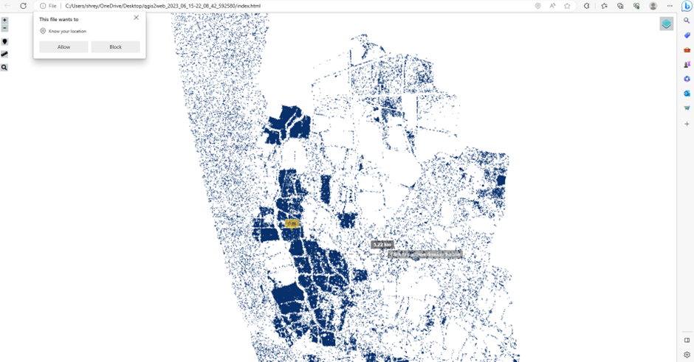

Figure 3: Qgis2web WMS

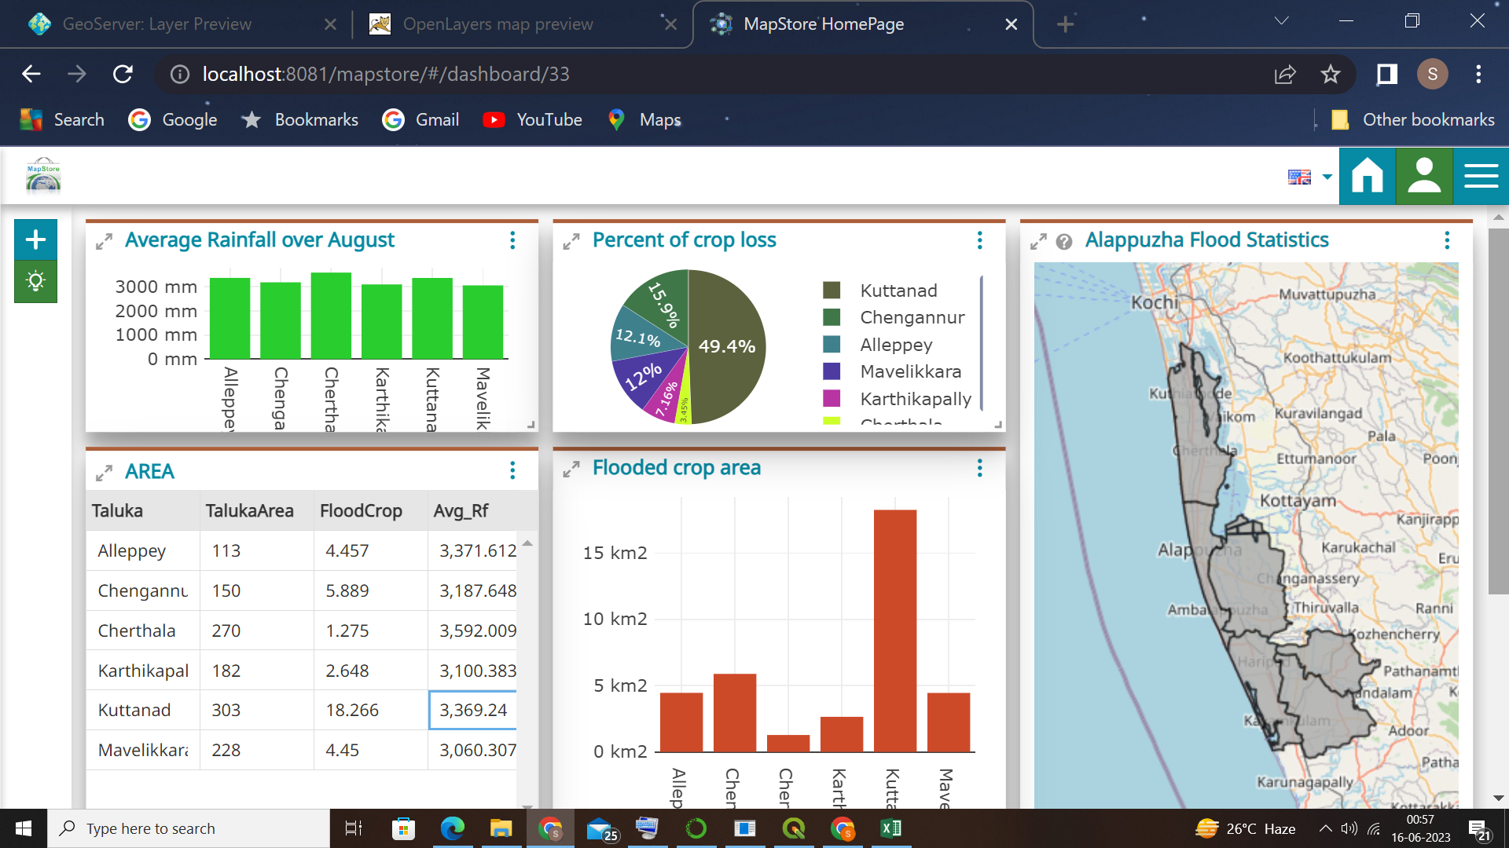

Figure 4: Geoserver Dashboard

GitHub Repository Link: <https://github.com/shreyassreesailam/CropInsuarnceWorkflow.git>